# Problem 2.Expense Tracker

**Environment Specifics**

Please be aware that every JS environment may **behave differently** when executing code. Certain things that work in the browser are not supported in **Node.js**, which is the environment used by **Judge**.

The following actions are **NOT** supported:

* **.forEach()** with **NodeList** (returned by **querySelector()** and **querySelectorAll()**)
* **.forEach()** with **HTMLCollection** (returned by **getElementsByClassName()** and **element.children**)
* using the **spread-operator** (**...**) to convert a **NodeList** into an array
* **append()** (use only **appendChild()**)
* **prepend()**
* **replaceWith()**
* **replaceAll()**
* **closest()**
* **replaceChildren()**

If you want to perform these operations, you may use **Array.from()** to first convert the collection into an array.

**Use the provided skeleton to solve this problem.**

**Note**: You **can't** and you have no permission to **change** directly the given HTML code (index.html file).

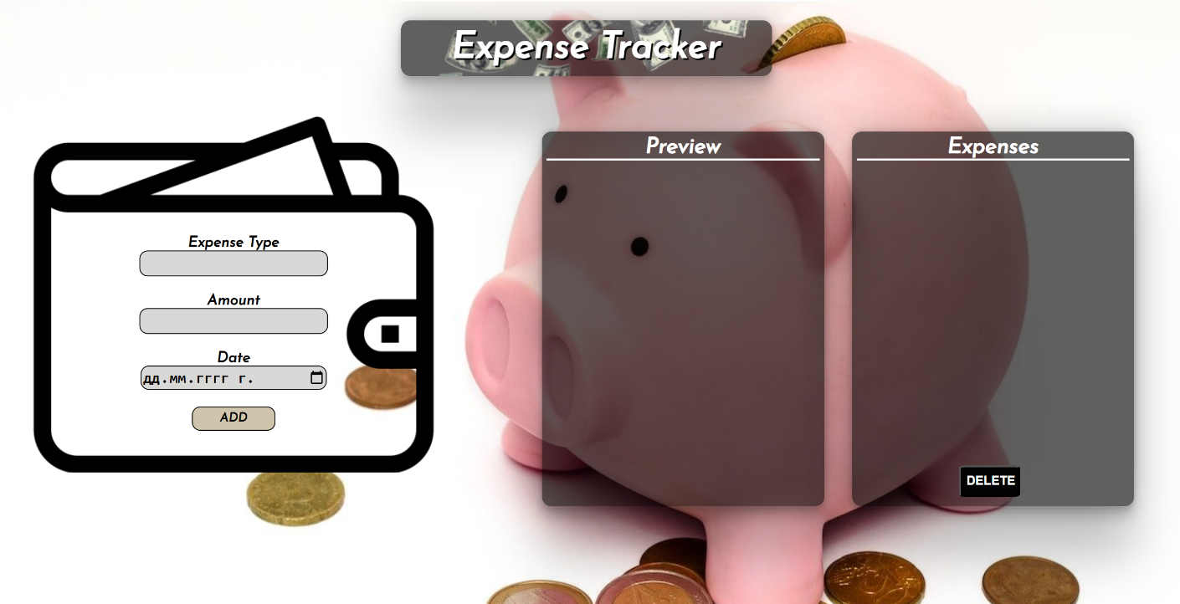

**Your Task**

**Write the missing JavaScript code** to make the **Expense Tracker** work as expected:

* + **Expense Type, Amount,** and **Date** should be **non**-**empty** **strings**. If any of them are empty, the program should not do anything.

1. **Get the information from the form**

When you click the **[Add]** button, the information from the input fields must be added to the <ul> with the id "preview-list", the **[Add]** button must be **disabled** and **the input fields should be cleared**.

The HTML structure should look like this:

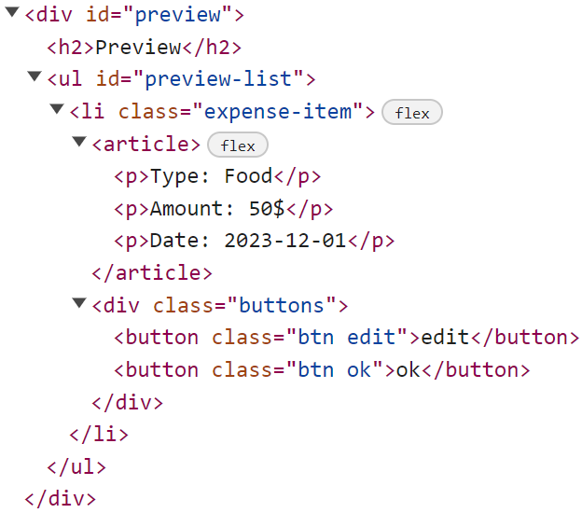

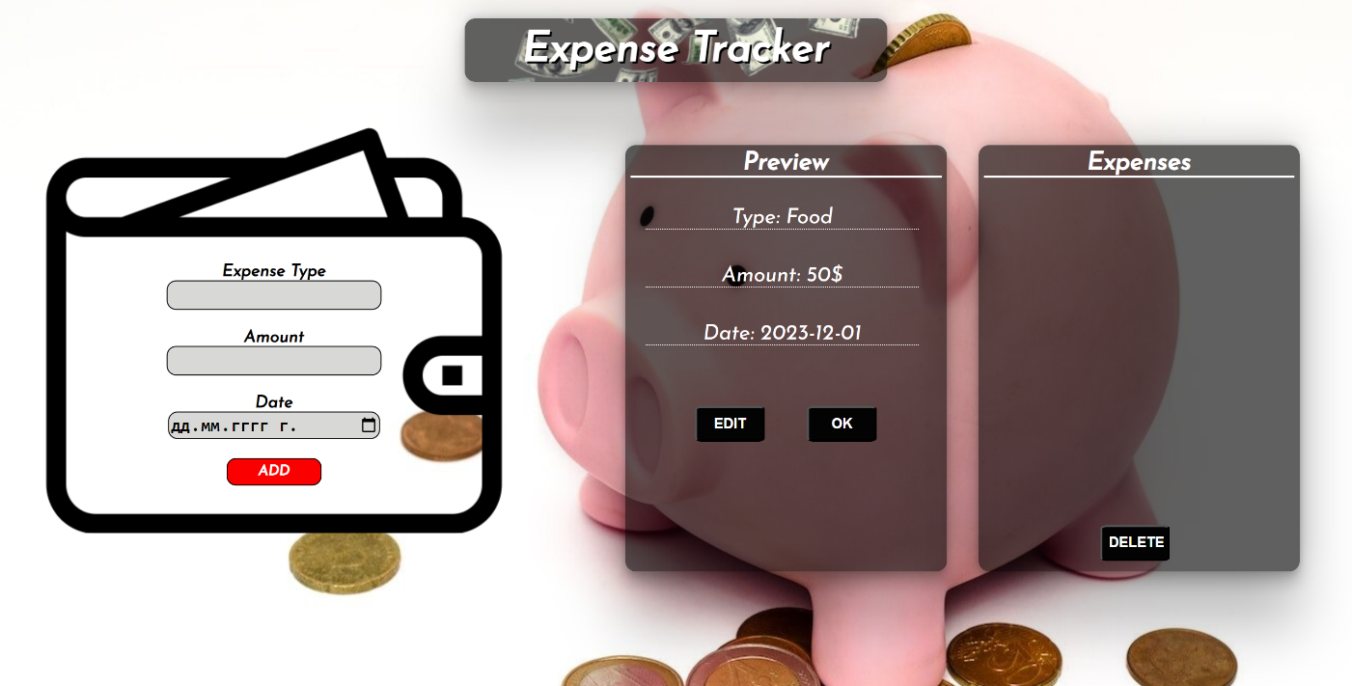

# Edit the Information

When the **[Edit]** button is clicked, the information from the post must be sent to the input fields on the left side, the record should be deleted from the <ul> "preview-list" and **[Add]** button must be **enabled** again.

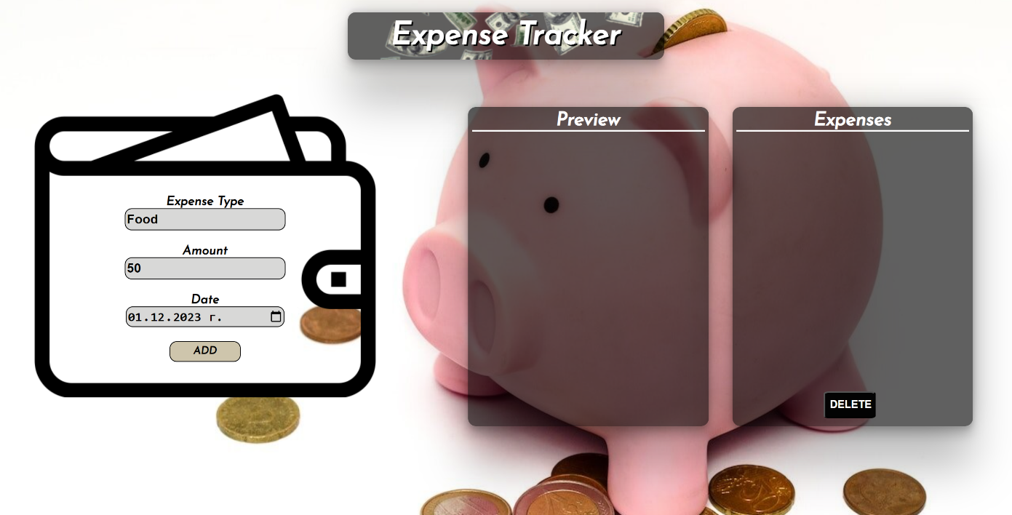

After editing the information, add a new item to the <ul> with the updated information.

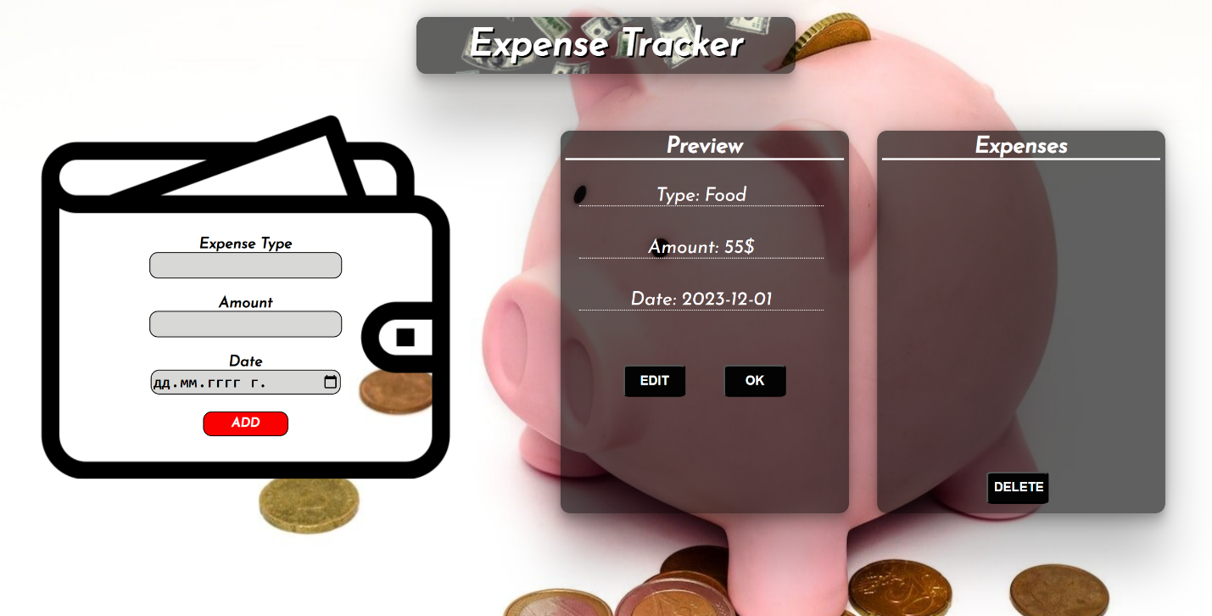

# Add to Expenses

When you click the **[Ok]** button, the record must be **deleted** from the <ul>withid"preview-list" and appended to the <ul> with id "expenses-list".

The **buttons [Edit]** and **[Ok]** should be removed from the <li> element and the **[Add]** button must be **enabled** again.

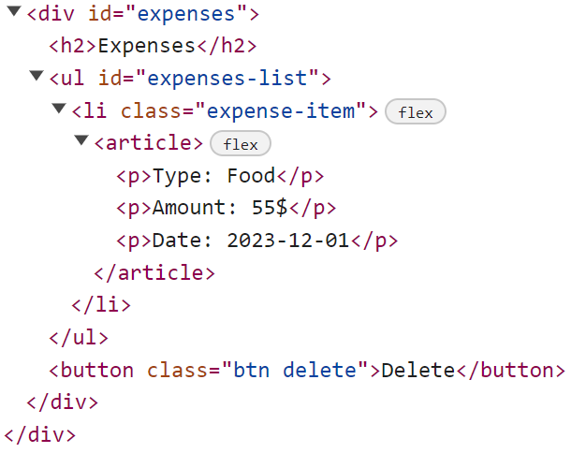 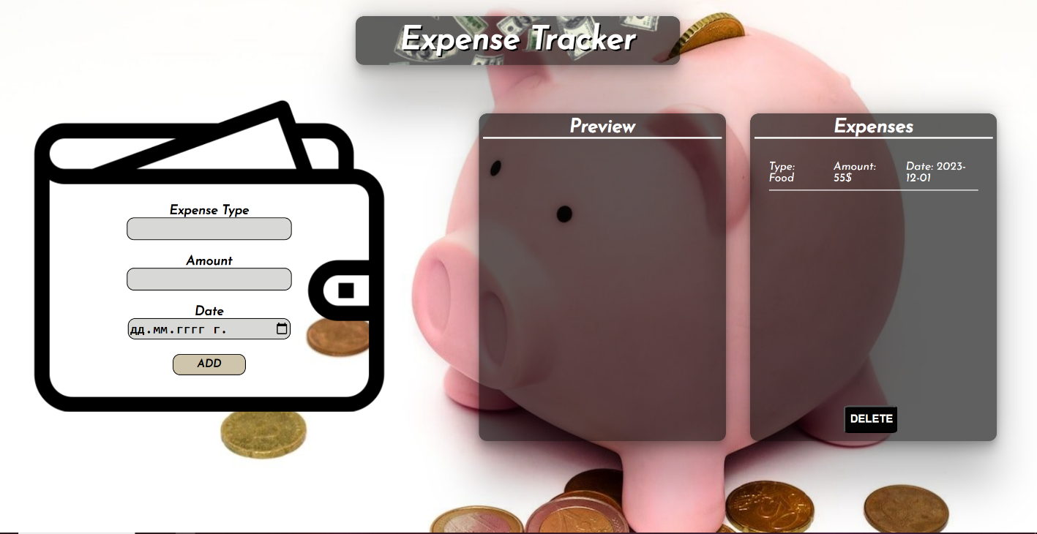

# Delete Expenses

When the **[Delete]** button is clicked, you must **reload** the application**.**

**Submission**

Submit only your **solve()** function.